**Uthraa Organics**

Colour Palette:

|  |  |  |
| --- | --- | --- |
| Code | Name | Pick |
| #687C63 | Burnt Sage |  |
| #E5DDD1 | Griege |  |

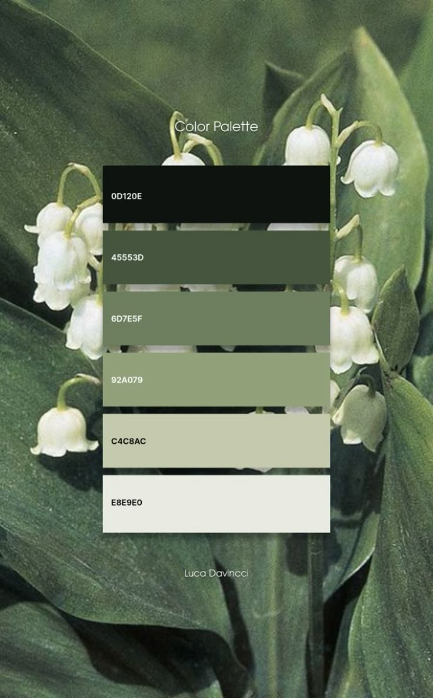

|  |  |  |
| --- | --- | --- |
| N | MODULE | DESCRIPTION |
| 1 | Authentication | Phone Number |
| 2 | Information Form | Address |
| 3 | Home Showcase | * New Arrivals * Best Sellers * Based on previous Orders |
| 4 | Shopping Page | * Filter & Search * Product Cards * Suggestions * Sidebar Cart |
| 5 | Categories | * Category Cards * Navigation Buttons * Sub-categories * Delivery Speeds |
|  | Order History | * Previous Orders * Reorder Products * Bill Invoice Display * Help on Orders |
|  | Product Display | * Product Description * Reviews * Similar Products * Familiarity |
|  | Wish List | * Added Products * Similar Stuffs * Set Remainder |
|  | Customized Products | * Get Attributes * Allow Photo Upload * Link to Canva |
|  | About US | * General Info * Product Processing * How we reach you |
|  | ERROR 404 | * Not Found Page * Network Problem Page * Data Inconsistency |
|  | News Letters | * Get Updates * New Arrivals * Discounts Notify |
|  | Shipment Tracking | * Order Successful * Generate Trans ID * Dispatched * Delivered |
|  | Order Returns | * Damage on transit * Wrong product * Mismatch |
|  | Manage Address | * Allow adding Addresses * Detect current Locations * Delete Addresses * Edit Addresses * Tag Addresses |
|  |  |  |